**Junit Advance Testing**

**Exercise 1: Parameterized Tests**

**Scenario:**

You want to test a method that checks if a number is even. Instead of writing multiple test

cases, you will use parameterized tests to run the same test with different inputs.

Steps:

1. Create a new Java class `EvenChecker` with a method `isEven(int number)`.

2. Write a parameterized test class `EvenCheckerTest` that tests the `isEven` method with

different inputs.

3. Use JUnit's `@ParameterizedTest` and `@ValueSource` annotations

**Code**

**Evenchecker.java**

package com.example;

public class EvenChecker {

public boolean isEven(int number) {

return number % 2 == 0;

}

}

**EvenCheckerTest.java**

package com.example;

import static org.junit.jupiter.api.Assertions.*;

import org.junit.jupiter.params.ParameterizedTest;

import org.junit.jupiter.params.provider.ValueSource;

public class EvenCheckerTest {

EvenChecker checker = new EvenChecker();

@ParameterizedTest

@ValueSource(ints = {2, 4, 6, 8, 10})

void testIsEvenTrue(int number) {

assertTrue(checker.isEven(number));

}

@ParameterizedTest

@ValueSource(ints = {1, 3, 5, 7, 9})

void testIsEvenFalse(int number) {

assertFalse(checker.isEven(number));

}

}

**Output**

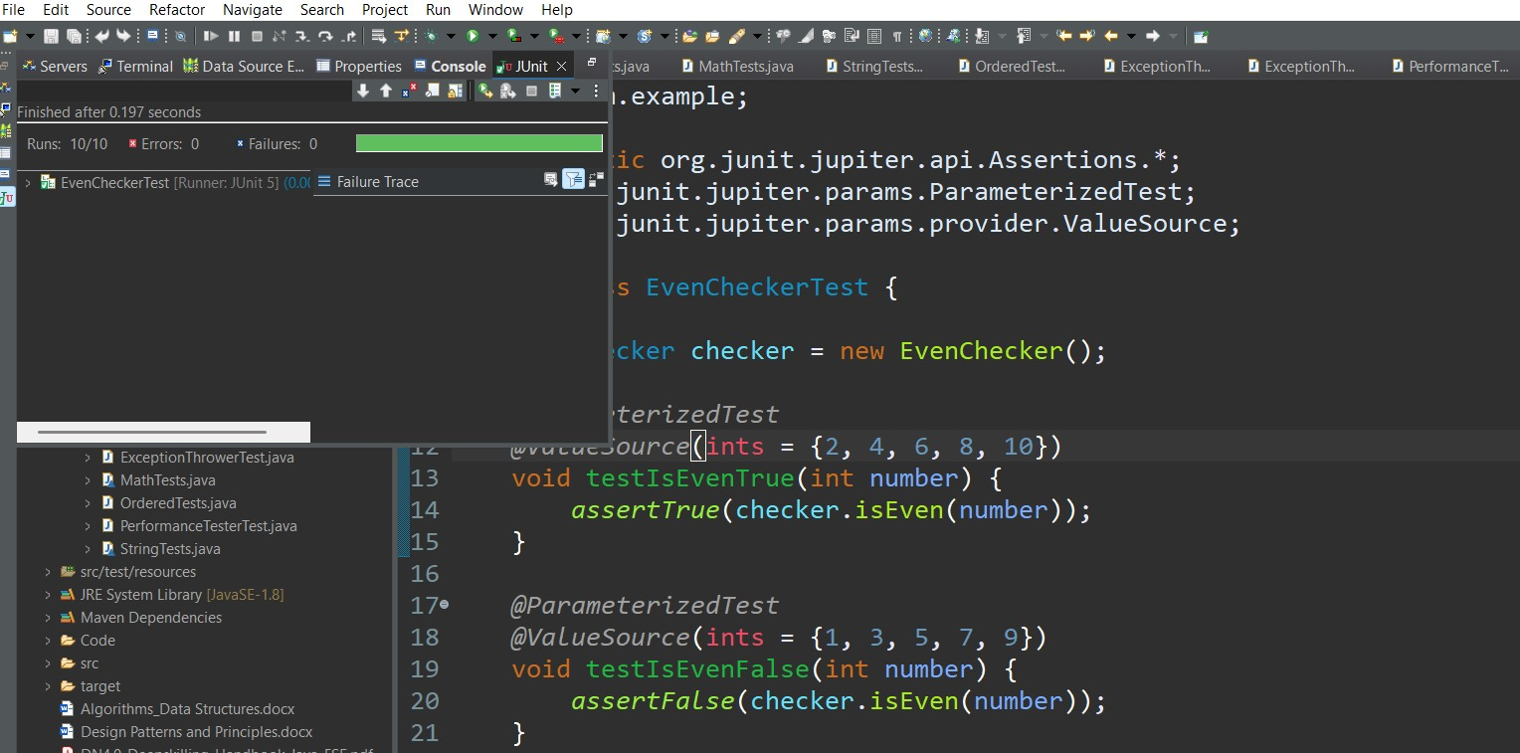

**Exercise 2: Test Suites and Categories**

Scenario:

You want to group related tests into a test suite and categorize them.

Steps:

1. Create a new test suite class `AllTests`.

2. Add multiple test classes to the suite.

3. Use JUnit's `@Suite` and `@SelectClasses` annotations.

**Code**

**MathTests.java**

package com.example;

import static org.junit.jupiter.api.Assertions.*;

import org.junit.jupiter.api.Test;

class MathTests {

@Test

void testAdd() {

assertEquals(4, 2 + 2);

}

}

**StrinTests.java**

package com.example;

import static org.junit.jupiter.api.Assertions.*;

import org.junit.jupiter.api.Test;

class StringTests {

@Test

void testLength() {

assertEquals(5, "Hello".length());

}

}

**AllTests.java**

**package** com.example;

**import** org.junit.platform.suite.api.SelectClasses;

**import** org.junit.platform.suite.api.Suite;

@Suite

@SelectClasses({

MathTests.**class**,

StringTests.**class**

})

**public** **class** AllTests {

// This class runs the selected test classes as a suite

}

**Output**

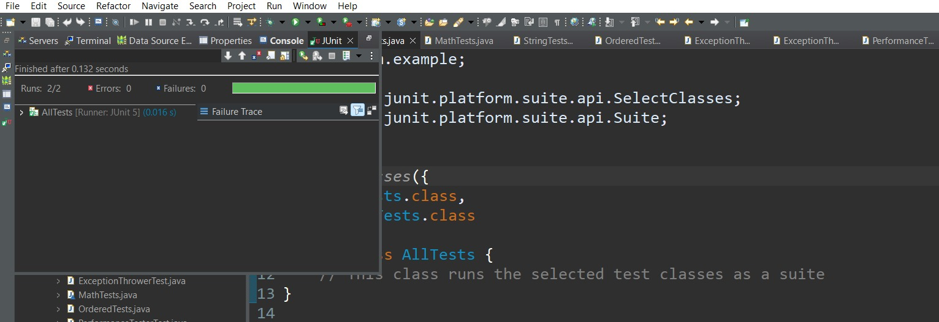

**Exercise 3: Test Execution Order**

**Scenario:**

You want to control the order in which tests are executed.

Steps:

1. Create a test class `OrderedTests`.

2. Use JUnit's `@TestMethodOrder` and `@Order` annotations.

**OrderedTests.java**

package com.example;

import static org.junit.jupiter.api.Assertions.*;

import org.junit.jupiter.api.*;

@TestMethodOrder(MethodOrderer.OrderAnnotation.class)

public class OrderedTests {

@Test

@Order(1)

void testA() {

System.*out*.println("Running testA");

*assertTrue*(true);

}

@Test

@Order(3)

void testC() {

System.*out*.println("Running testC");

*assertTrue*(true);

}

@Test

@Order(2)

void testB() {

System.*out*.println("Running testB");

*assertTrue*(true);

}

}

**Output**

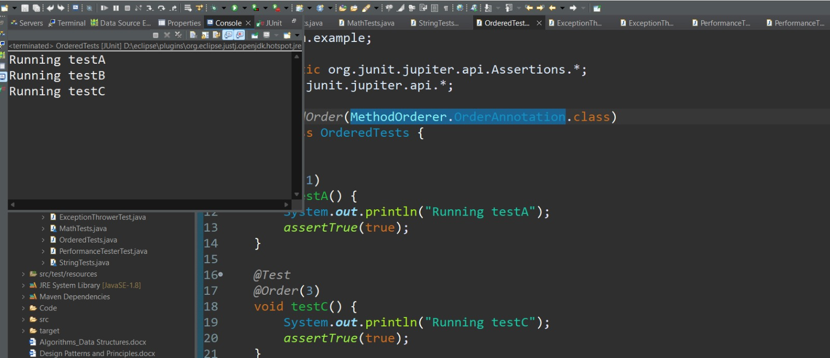

**Exercise 4: Exception Testing**

**Scenario:**

You want to test that a method throws the expected exception.

Steps:

1. Create a class `ExceptionThrower` with a method `throwException`.

2. Write a test class `ExceptionThrowerTest` that tests the method for the expected

exception.

**Code**

**ExceptionThrower.java**

package com.example;

public class ExceptionThrower {

public void throwException() {

throw new IllegalArgumentException("Invalid input!");

}

}

**ExceptionThrowerTest.java**

**package** com.example;

**import** **static** org.junit.jupiter.api.Assertions.*;

**import** org.junit.jupiter.api.Test;

**public** **class** ExceptionThrowerTest {

@Test

**void** testExceptionThrown() {

ExceptionThrower thrower = **new** ExceptionThrower();

Exception exception = *assertThrows*(IllegalArgumentException.**class**, () -> {

thrower.throwException();

});

*assertEquals*("Invalid input!", exception.getMessage());

}

}

**Output**

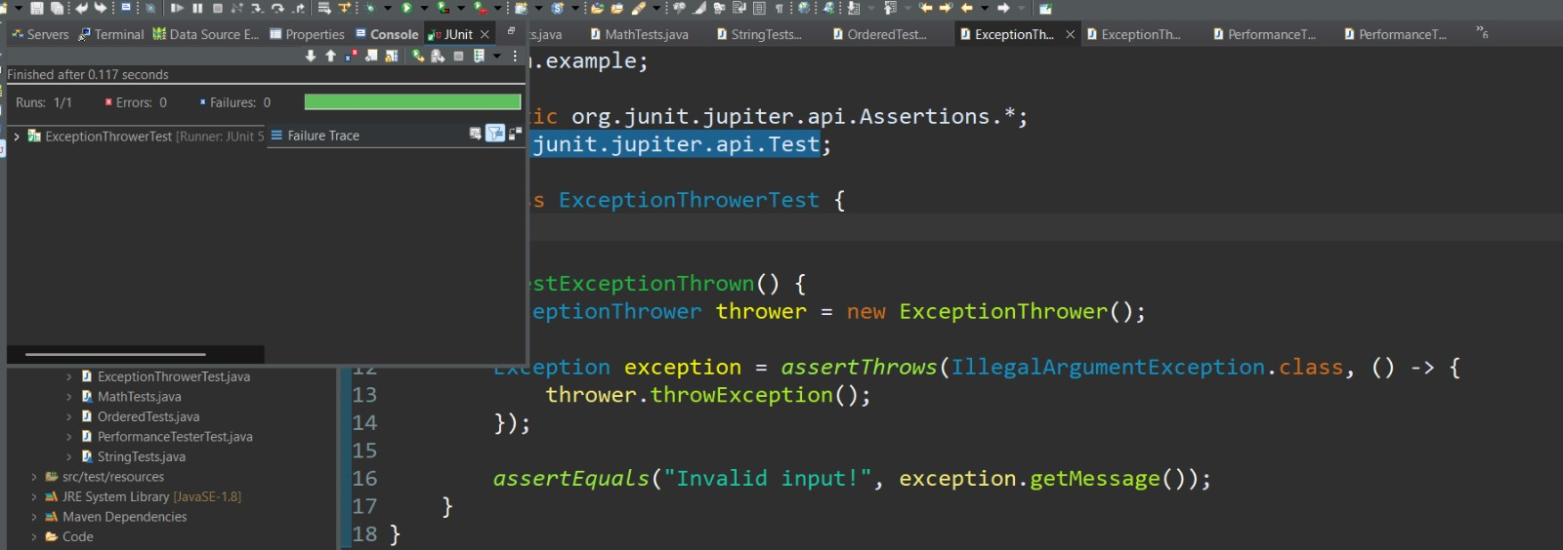

**Exercise 5: Timeout and Performance Testing**

**Scenario:**

You want to ensure that a method completes within a specified time limit.

Steps:

1. Create a class `PerformanceTester` with a method `performTask`.

2. Write a test class `PerformanceTesterTest` that tests the method for timeout.

**Code**

**PerformaceTest.java**

package com.example;

public class PerformanceTester {

public void performTask() throws InterruptedException {

// Simulate work

Thread.sleep(500); // 500ms

}

}

**PerformanceTesterTest.java**

package com.example;

import org.junit.jupiter.api.Test;

import org.junit.jupiter.api.Timeout;

import java.util.concurrent.TimeUnit;

public class PerformanceTesterTest {

@Test

@Timeout(value = 1, unit = TimeUnit.SECONDS)

void testPerformanceWithinTimeout() throws InterruptedException {

PerformanceTester tester = new PerformanceTester();

tester.performTask();

}

}

**Output**

